IOT-PHASE 2

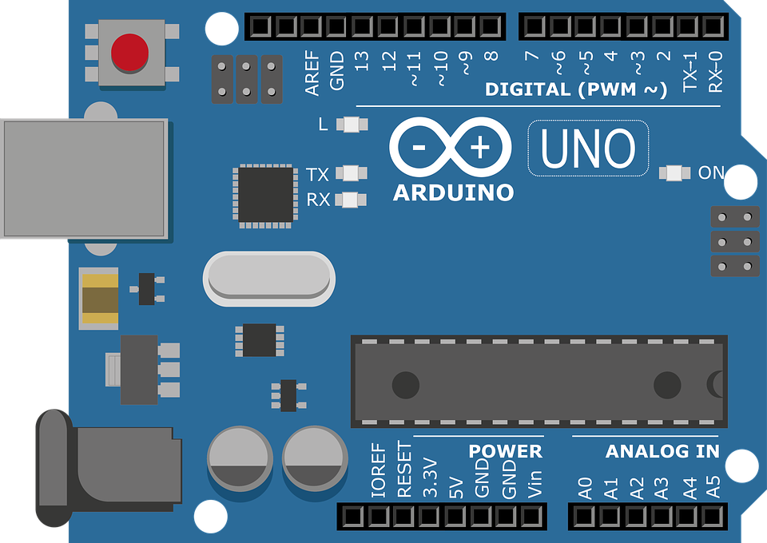SMART WATER SYSTEM

# INTRODUCTION:

Modern methods for utilizing Arduino to manage water resources wisely include smart water-based systems. These systems can track and manage water use in a variety of applications by merging Arduino microcontrollers with sensors like moisture detectors, flow meters, and water level sensors. Arduino-based smart water systems offer real-time data and automation capabilities, making them ideal for controlling irrigation in agriculture, controlling water levels in tanks or reservoirs, and even finding problems in household plumbing. These systems not only conserve water but also cut costs and encourage sustainable methods of water management since they have the capacity to gather data, evaluate it, and make informed judgments. They are adaptable and available technology for both people and businesses interested in water conservation since they can be scaled and adjusted to meet varied needs.

# principle:

A smart water-based system based on Arduino collects data from sensors, processes it using Arduino microcontrollers, and then uses this information to automate and optimize water-related functions such as irrigation, water level control, and leak detection. Through real-time monitoring and intelligent decision-making, it encourages efficient water usage and conservation.

# design principle:

The design concepts for an Arduino-based smart water-based system should focus on building a dependable, efficient, and user-friendly solution. Consider the following fundamental design principles:

1. **Scalability:** Make the system scalable so that it can be easily expanded or adapted to handle different sizes and types of water management jobs.
2. Modular components and standardized interfaces are used to facilitate maintenance, upgrades, and repairs.
3. **Energy Efficiency:** Optimize power consumption to ensure the system performs efficiently, particularly if it is powered by a battery or solar panels.
4. **Data Accuracy:** Select high-quality sensors and assure calibration in order to obtain accurate data for informed decision-making.
5. **Redundancy:** To improve system reliability, include redundancy wherever possible, such as backup power sources or multiple sensors.
6. Create an easy user interface, whether through a mobile app or a web portal, to allow users to quickly monitor and control the system.
7. Implement security measures to safeguard data and prevent unwanted access.

# BLOCK DIAGRAM:

The developed system is utilized for water monitoring and quality control. The sensor in the base tank first detects the presence of water. When there is water, the pump starts automatically and begins pumping water to the overhead tank. Different water levels in the over head tank are monitored. When the water reaches the chosen threshold, the user is notified. When the water level reaches the maximum level, the pump shuts down automatically. If water flows continuously for longer than predicted, the water flow sensor will notice it and send the data to the IOT server.

ggg

The user can view real-time data in the IOT server, and in this case, one notification will be transmitted from the IOT server to the mobile app. If the PH level of the water or the dirt level is not acceptable, the water will not be pumped into the tank. The user can manage the flow of water by engaging with the server via the mobile app.

## system workflow:

The overall workflow of the system in the public places is given as



# COMPONENTS USED:

1. **Sensors:**
   * Water Level Sensors: Measure water levels in tanks and reservoirs.
   * Water Quality Sensors: Monitor parameters like pH, turbidity, and contaminants.
   * Temperature Sensors: Measure water temperature for quality control.
   * Flow Sensors: Monitor water flow rates in distribution systems.
   * Rainfall Sensors: Detect and measure precipitation for rainwater harvesting.
2. **Data Acquisition System:**
   * Microcontrollers or PLCs (Programmable Logic Controllers): Collect data from sensors.
   * Data Transmitters: Transmit data to the central control unit via wired or wireless connections.
3. **Central Control Unit:**
   * Central Processing Unit (CPU): Processes incoming data and makes decisions.
   * Control Software: Runs algorithms for system optimization.
   * Database: Stores historical data for analysis.
4. **User Interface:**
   * Human-Machine Interface (HMI): Touchscreen displays or web-based interfaces for user interaction.
   * Mobile Applications: Smartphone apps for remote monitoring and control.
5. **Communication Network:**
   * Ethernet/Wi-Fi/Cellular Connectivity: Provides data transmission capabilities.
   * Communication Protocols: MQTT, HTTP, TCP/IP for data exchange.
6. **Water Storage Tanks:**
   * Tanks and Reservoirs: Store collected water for later use.
7. **Water Distribution System:**
   * Pipes and Valves: Transport and control the flow of water to various endpoints.
   * Water Dispensers: Provide drinking water.
   * Irrigation Systems: Water plants and landscaping.
   * Restroom Fixtures: Manage water supply in public restrooms.
8. **Water Treatment Units:**
   * Filtration Systems: Remove impurities from water.
   * UV Purifiers: Disinfect water to ensure safety.
   * Chemical Injection Systems: Add water treatment chemicals as needed.
9. **Monitoring and Control:**
   * Control Algorithms: Implement logic for efficient water distribution.
   * Remote Control Devices: Allow manual intervention when necessary.
10. **Alerts and Notifications:**
    * Alarms and Notifications: Inform administrators and users of system status and issues.
    * Email/SMS Alerts: Send messages for urgent situations.
11. **Feedback Loop:**
    * User Feedback Mechanisms: Surveys, reporting tools for users and administrators.
    * Data Analytics: Analyze data for system performance improvement.
12. **Maintenance and Service:**
    * Maintenance Schedule Software: Schedule and track maintenance tasks.
    * Service Teams: Technicians for system upkeep.
13. **Power Supply:**
    * Grid Power: Primary power source.
    * Solar Panels: Provide renewable energy in some cases.
    * Backup Batteries: Ensure uninterrupted operation during power outages.
14. **Security and Access Control:**
    * Access Control Systems: Restrict physical access to critical components.
    * Encryption and Authentication: Secure data transmission and access.

# PROCEDURE:

The major steps in a Smart Water Management System are outlined in this simplified approach.

1. **Sensor Installation:**
   * Install sensors to measure water levels, quality, temperature, and flow at key points in the public area.
2. **Data Gathering:**
   * Sensors collect data and send it to a central control unit through wires or wireless connections.
3. **Central Control Unit:**
   * The central unit processes the data and makes decisions about water usage and distribution.
4. **User Interface:**
   * A user-friendly interface, like a smartphone app or touchscreen display, allows people to check water status and control water features.
5. **Communication:**
   * Ensure that all components can communicate with each other using networks like Wi-Fi or cellular connections.
6. **Water Storage:**
   * Store collected water in tanks or reservoirs for later use.
7. **Water Distribution:**
   * Control valves and pipes distribute water to drinking fountains, restrooms, and irrigation systems as needed.
8. **Water Treatment:**
   * Purify and filter the water to ensure it's safe and clean for use.
9. **Monitoring and Optimization:**
   * The system continually monitors water levels and quality, adjusting distribution for efficiency.
10. **Alerts and Feedback:**
    * Send alerts to administrators and users for maintenance or issues.
    * Gather feedback from users to improve the system.

# CONCLUSION:

Water is one of the most basic needs of all living things. Our suggested system monitors water levels, checks water quality, and controls them via an Android application. This program allows the user to control the motor from any location and at any time. In today's society, the engine turns on and off automatically, but the quality of the water is not verified. As a result, in order to maintain the purity of the water, our system detects any items present in the storage tank.

It will come in handy when decomposable things are discovered in water. This aids in the prevention of accidents. The system's next development will be to discover commonly detected things in the storage tank and notify the user.

For huge databases, the cloud can be used.

1. **Data Gathering:**
   * **Sensors collect data and send it to a central control unit through wires or wireless connections.**
2. **Central Control Unit:**
   * **The central unit processes the data and makes decisions about water usage and distribution.**
3. **User Interface:**
   * **A user-friendly interface, like a smartphone app or touchscreen display, allows people to check water status and control water features.**
4. **Communication:**
   * **Ensure that all components can communicate with each other using networks like Wi-Fi or cellular connections.**
5. **Water Storage:**
   * **Store collected water in tanks or reservoirs for later use.**
6. **Water Distribution:**
   * **Control valves and pipes distribute water to drinking fountains, restrooms, and irrigation systems as needed.**
7. **Water Treatment:**
   * **Purify and filter the water to ensure it's safe and clean for use.**
8. **Monitoring and Optimization:**
   * **e system continually monitors water levels and quality, adjusting distribution for efficiency.**
9. **Alerts and Feedback:**
   * **Send alerts to administrators and users for maintenance or issues.**
   * **Gather feedback from users to improve the system.**